Question 5
- The graph is downwards sloping to low interest rates.
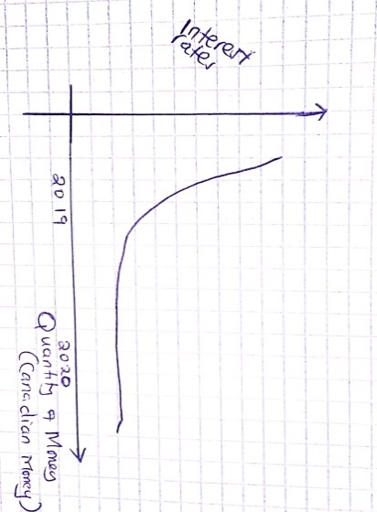
Low interest rates in the economy increase the money demand and supply; which in turn improves the living standards of the people affected by the pandemic.
- The short run asset approach; typically in the short-run prices are sticky and the exchange rate asset approach in considered to be valid. The interest-bearing account of various currencies tends to offer variables rates of nominal interest. Monetary forms might be required to deteriorate or appreciate against each other. There is a motivating force for exchange: financial backers will move assets starting with one country then onto the next until the normal pace of return (estimated in typical money) is balanced. Exchange in the unfamiliar trade (FX) market decides the present spot swapping scale, and the FX market is in harmony when the uncovered revenue equality condition holds.
- The use of interest rate as a monetary tool to correct the worsening exchange rate value. Lowering the interest rates tend to make the currencies deteriorate the exchange rates up-to a scaling relationship between the exchange rates.
- In the exchange rate currency devaluation tend to impact the balance of payment on the real money in the economy. Devaluating currency raises the balance of payment through increase in local prices that lowers the money supply in the economy which contributes to trade deficit and surplus.
- The increase in national saving will result to a fall in trade deficit; thus, they have an inverse relationship.

Question 8
- Expenditure changing policies are framework that impact employment and income sectors with the objective of equalizing with the national expenditure and can be either monetary or fiscal policies. While expenditure switching policies is a macroeconomic framework that impact the status of the national expenditure on domestic and foreign goods; such as balancing the current account by adjusting the spending of exports and imports such as tariffs and raising or lowering tax on countries expenditure.
- The government should use contractionary fiscal policies to lower deficit and increase in tariffs.
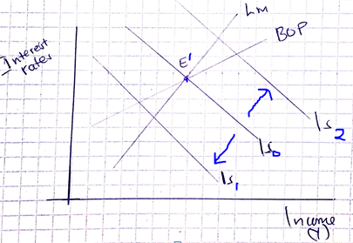
E¹; shows the original point
Is₁ shows the impact after contractionary monetary policies have been implemented

